 | CO2 Monitor Instructions

Date: | 29/05/21 | Version: | 1.0 | By: | Matt Little

This is an ESP8266 breakout board with small OLED display, a rotary encoder for user input and five Red-Green-Blue WS2812 LEDs.
This is designed as a low cost platform to quickly get started with projects with the ESP8266. We wanted to design something that got you up and running with your project idea quickly and easily.
The main processor is based upon the ESP8266 system-on-chip from Espressif Systems.
This can be programmed via the Arduino IDE.
This is a reasonably simple kit which requires some soldering.

This kit requires a micro-USB lead for programming and powering the unit.
Not suitable for under 12 years old.

Parts included:
 |  |  | 5 x 100nf Capacitors |  |  | 500mA Fuse |  | 2 x 1N5819  Diodes
PCB  with LEDs, level shifter and micro USB pre-soldered | 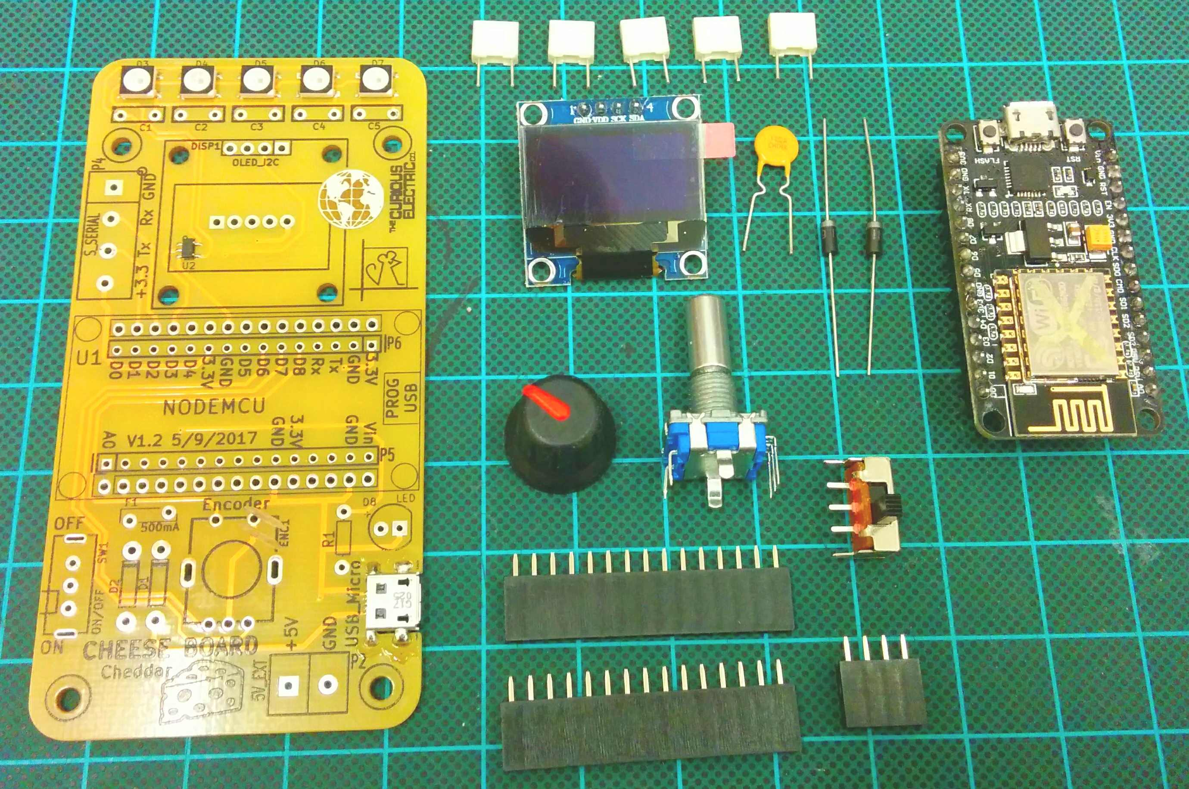 |  |  |  |  |  |  | 2 x 1N5819  Diodes
PCB  with LEDs, level shifter and micro USB pre-soldered |  |  |  |  |  |  |  | ESP8266  NodeMCU  Amica
 |  |  |  |  |  |  |  | Rotary Encoder
 |  |  |  |  |  |  |  | Switch
OLED
Display
 |  | Knob |  |  | 2 x 15 pin headers |  | 4 way header

Parts list:
Item | Ref | Quantity
Capacitors. 100nf | C1-5 | 5
Diode. 1N5819 | D1, D2 | 2
LED. WS2812 (pre soldered) | D3-7 | 5
LED. Red. NOT included | B8 | Not Included
Display. OLED. 0.96"  With 4-way header | DISP1 | 1
Encoder | ENC1 | 1
Fuse. 500MA | F1 | 1
USB micro Socket (pre-soldered) | P1 | 1
2 way screw terminal. 5V | P2 | 1
HC-11 Serial. Optional | P3
Software Serial. Optional | P4
Node MCU header. 15 way. | P5, P6 | 2
PCB – with SMD parts soldered |  | 1
330ohm Resistor | R1 | 1
Switch | SW1 | 1
NodeMCU  with 2 x 15 way headers | U1 | 2
74LVC1G17 Level shifter (pre-soldered) | U2 | 1

Enclosure Parts:
 |  | Spacer
 | 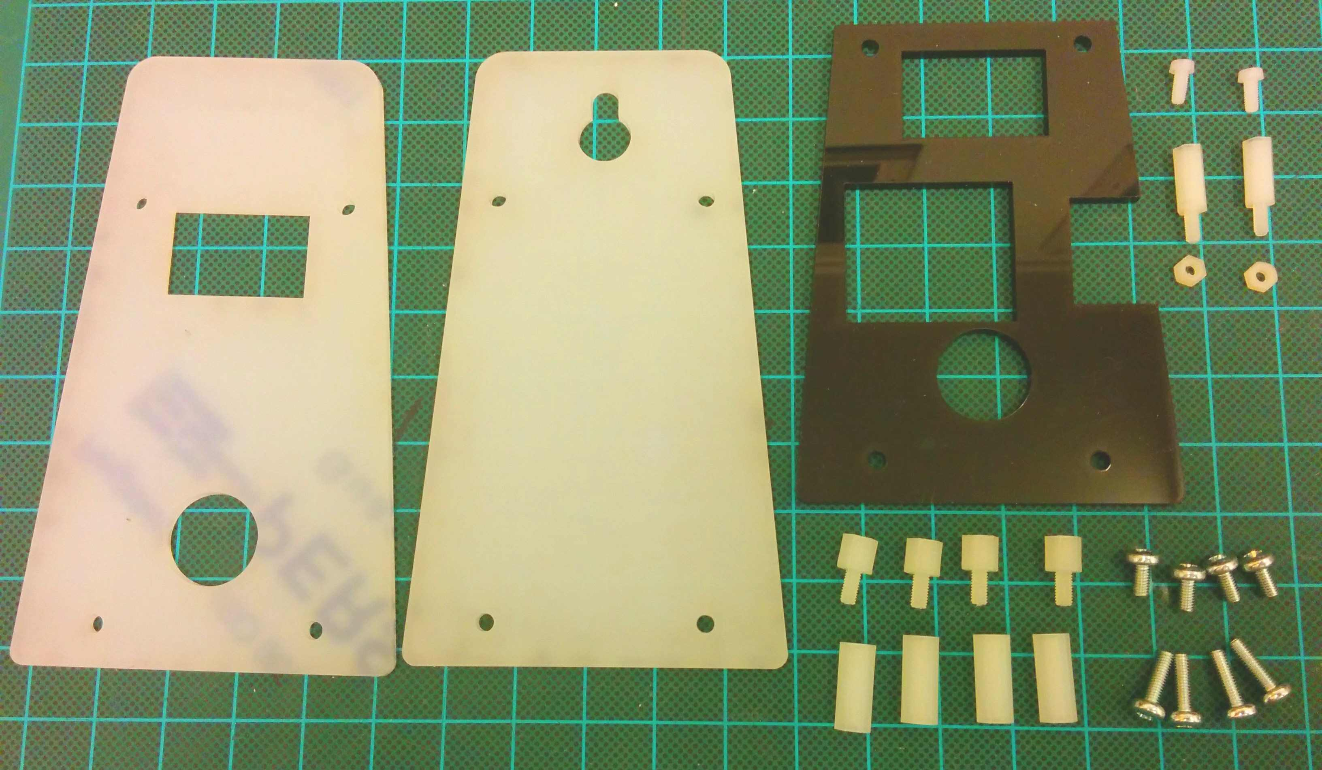
Front |  | M2 Screws
 |  | M2 12mm spacer
 |  | M2 nuts
Back
 |  | M3 6mm spacer
 |  | M3 6mm screws
 |  | M3 12mm screws
 |  | M3 15mm spacer

Hardware
Item | Ref | Quantity
M2 Machine screws. Plastic. 6mm long |  | 2
M2 Nuts. Plastic |  | 2
M2 Spacers. Plastic. 12mm long |  | 2
M3 Machine screws. 6mm long |  | 4
M3 Machine screws 12mm long |  | 4
M3 Threaded Hex spacers. 8mm long |  | 4
M3 Threaded Hex spacers. 15mm long |  | 4
Front. Laser cut 3mm Frosted Acrylic |  | 1
Spacer. Laser cut 3mm Black. Acrylic |  | 1
Back. Laser cut 3mm Frosted Acrylic |  | 1

Tools required:

 | 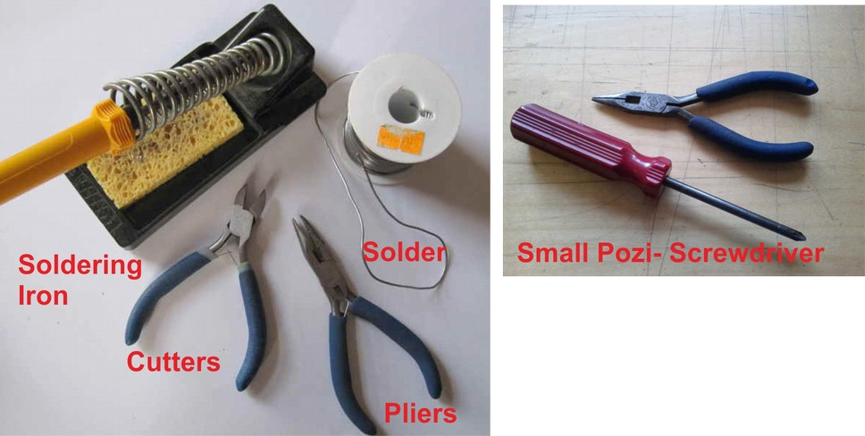
Long-nosed
Pliers
Soldering Iron |  | Posi-drive  Screwdriver
Solder
Side cutters
Additional Items Required
- 1 x Micro-USB lead (for powering and for programming)
- 1 x 5V USB power supply (might be required for powering stand-alone unit)
- Computer with Arduino IDE and additional libraries installed. (see software section for more details)

Instructions:
Step: 1 | Solder diodes
There are two diodes to solder in to the two components marked D1 and D2.  Ensure correct polarity! The white band on the diode should align with the black band on the PCB silkscreen. |  | 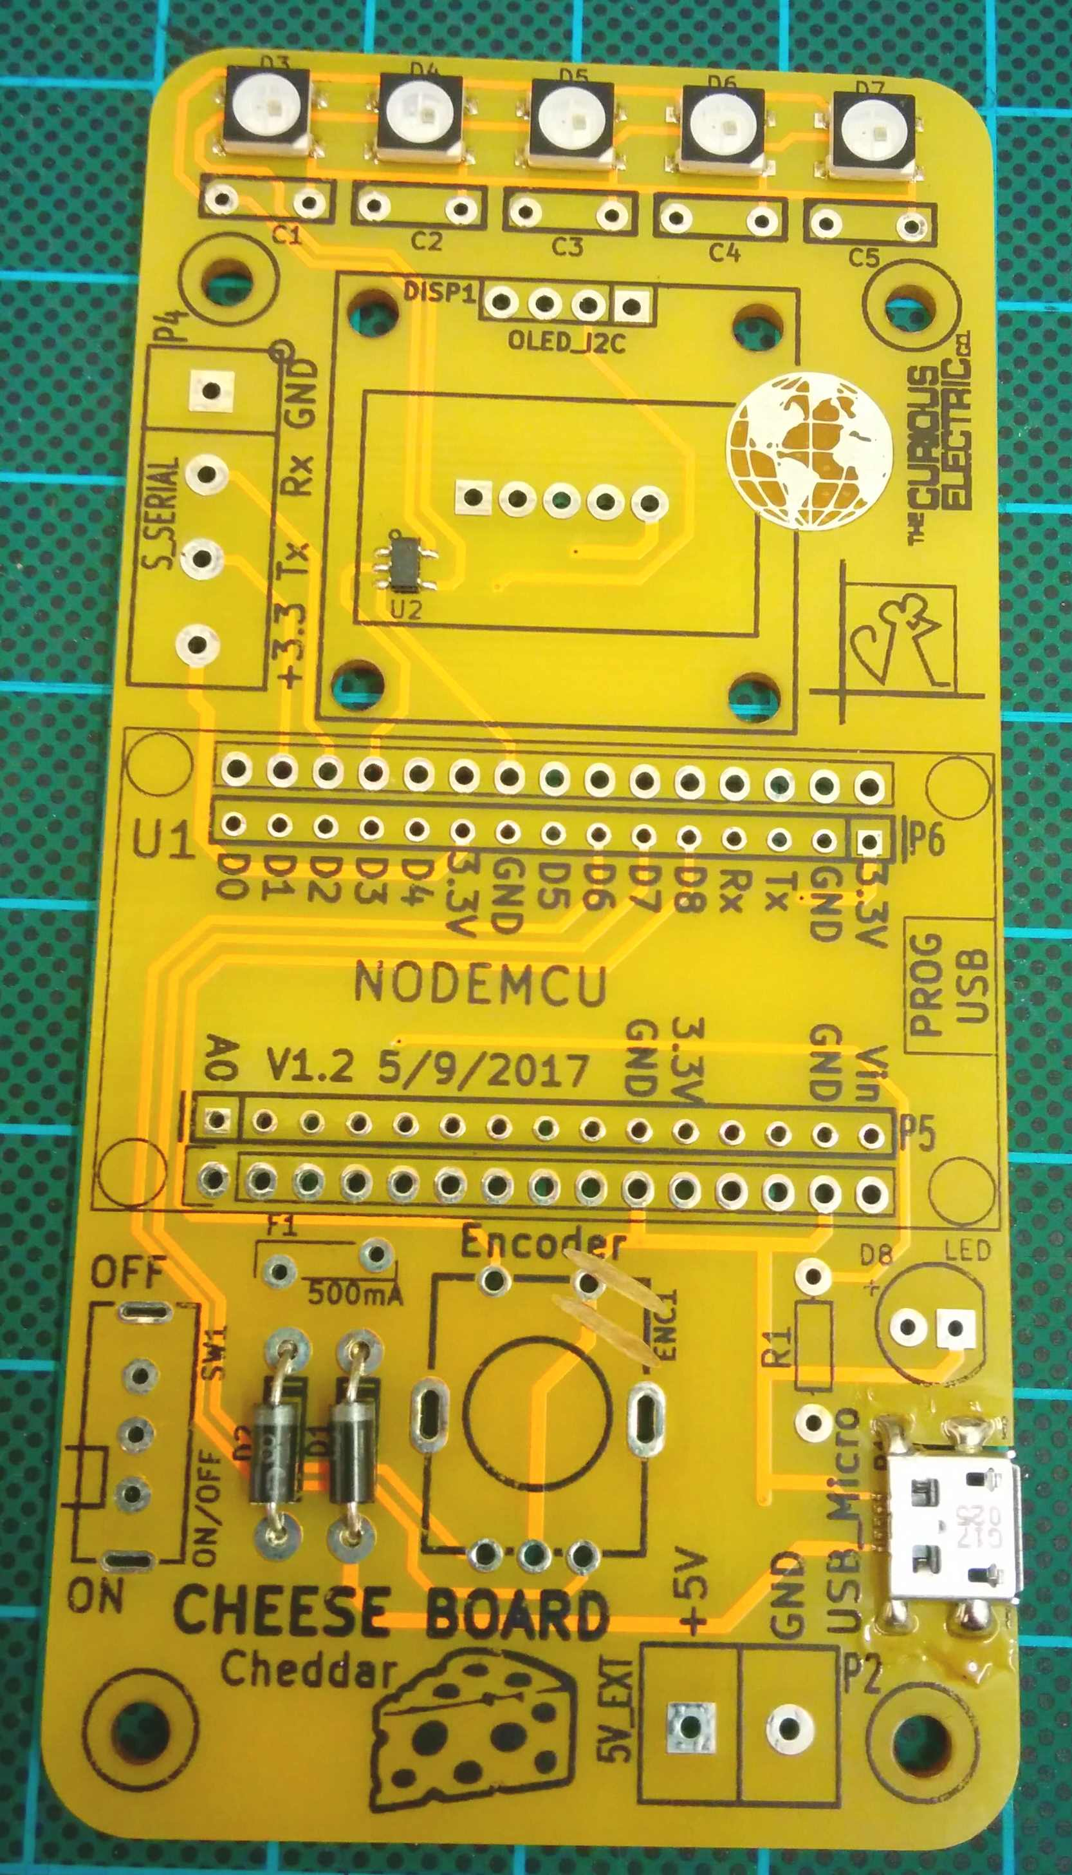  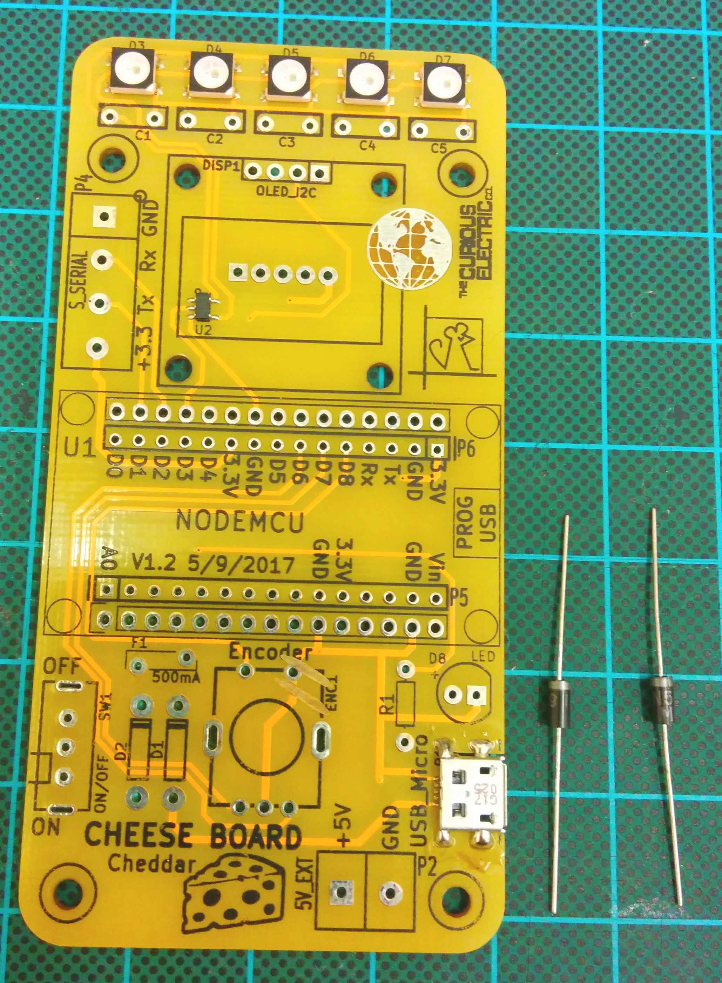

Step: 2 | Solder capacitors
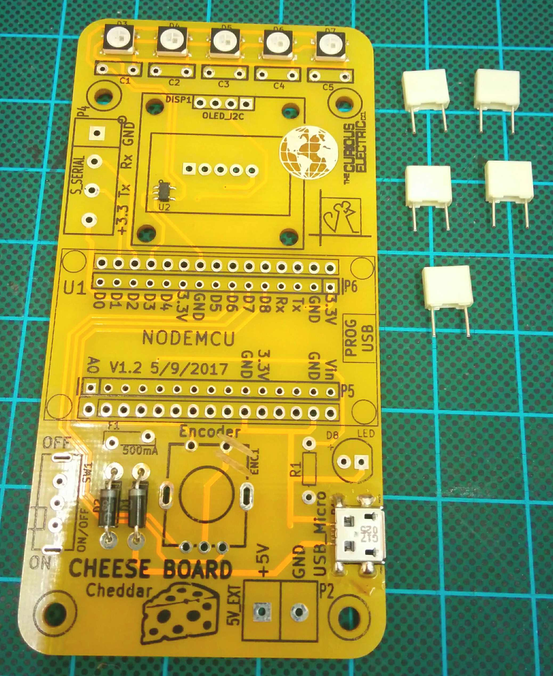  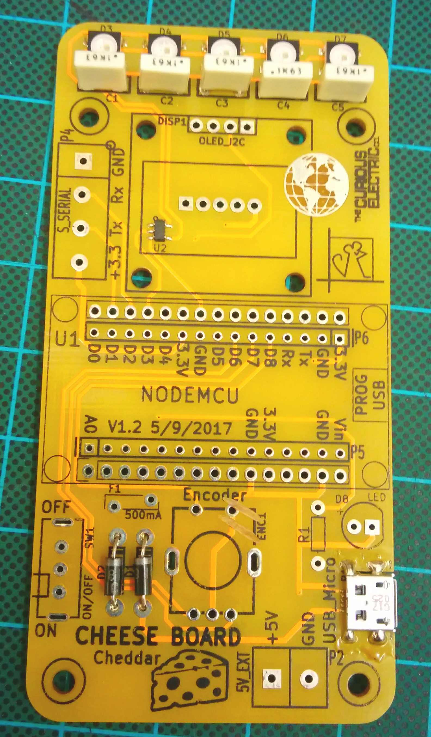 |  | There are five 100nf capacitors to solder in to the holes marked C1 to C5.  These capacitors do not have any polarity.

Step: 3 | Solder switch
The right angled switch should be soldered into SW1. |  | 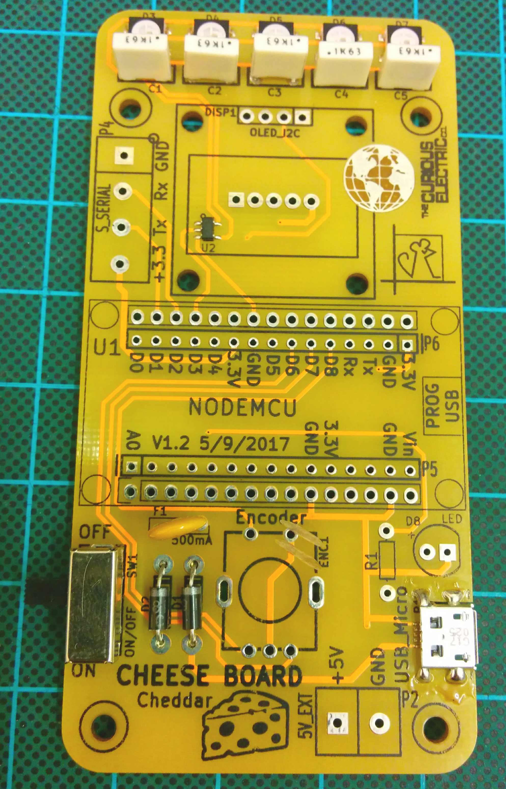  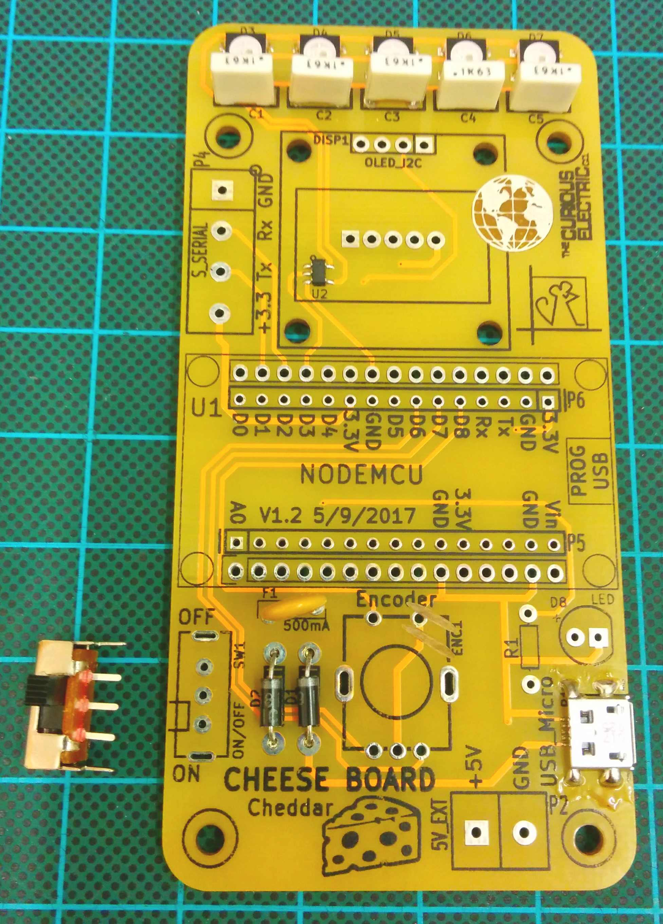

Step: 4 | Solder fuse
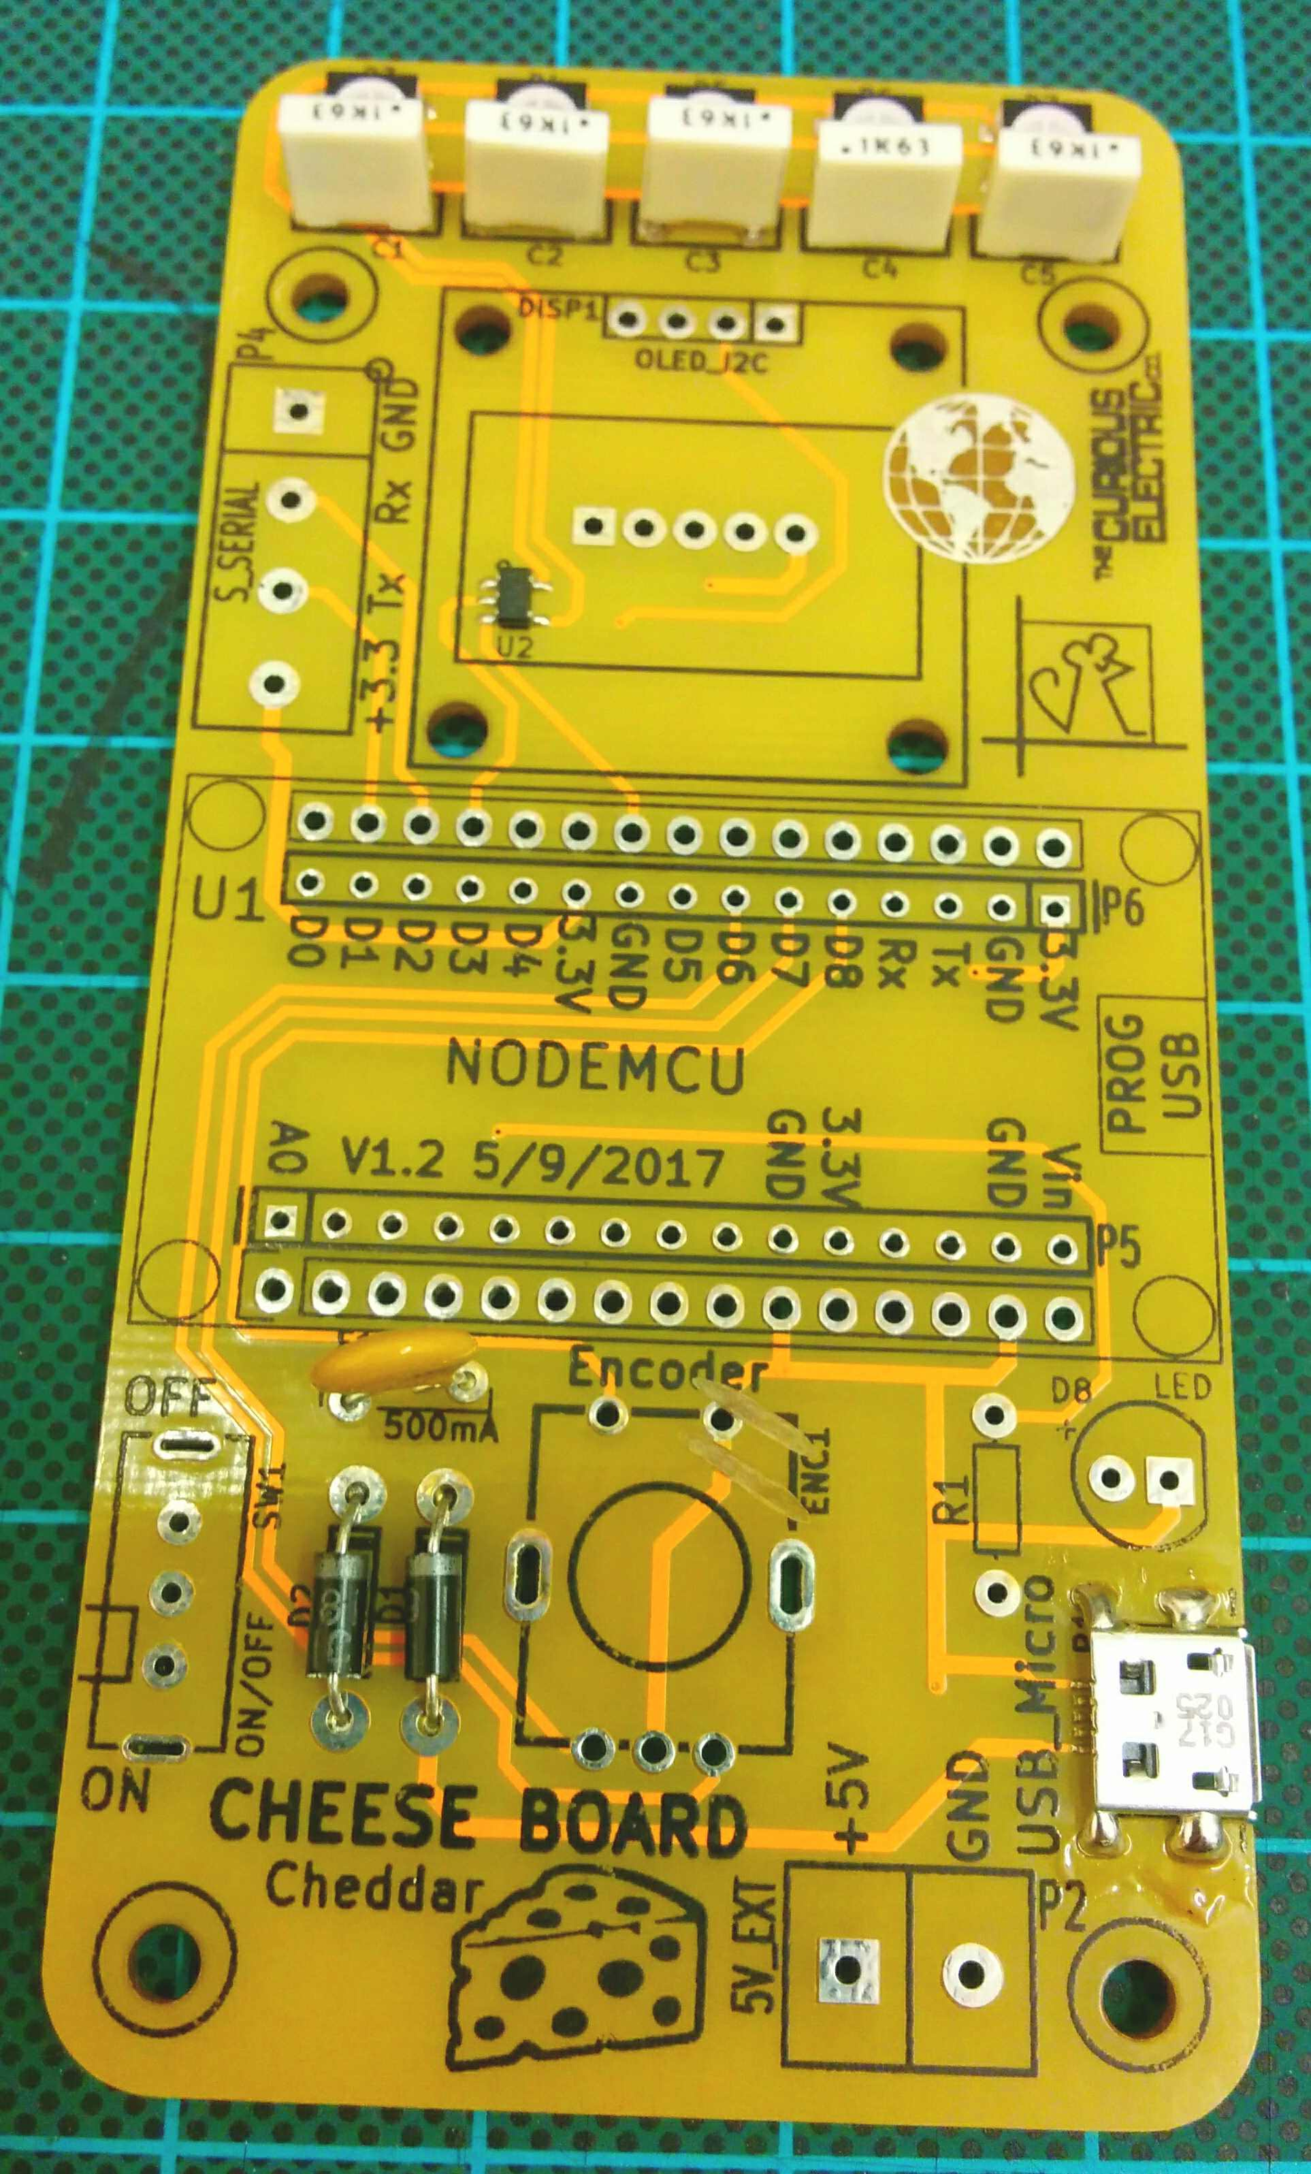  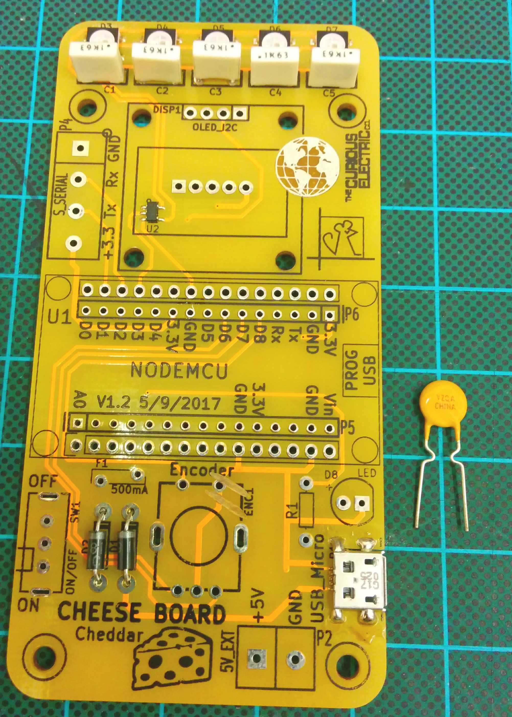 |  | The 500mA resettable fuse should be soldered into the hole marked F1.  The fuse does not have any polarity.

Step: 5 | Solder header pins
Solder the 4 way header block into the holes marked DISP1.  The 15 way headers are soldered into the NodeMCU area marked U1.  Do not sodler anything into the holes marked P5 and P6 – these are connections for any external circuits you might want to add. |  | 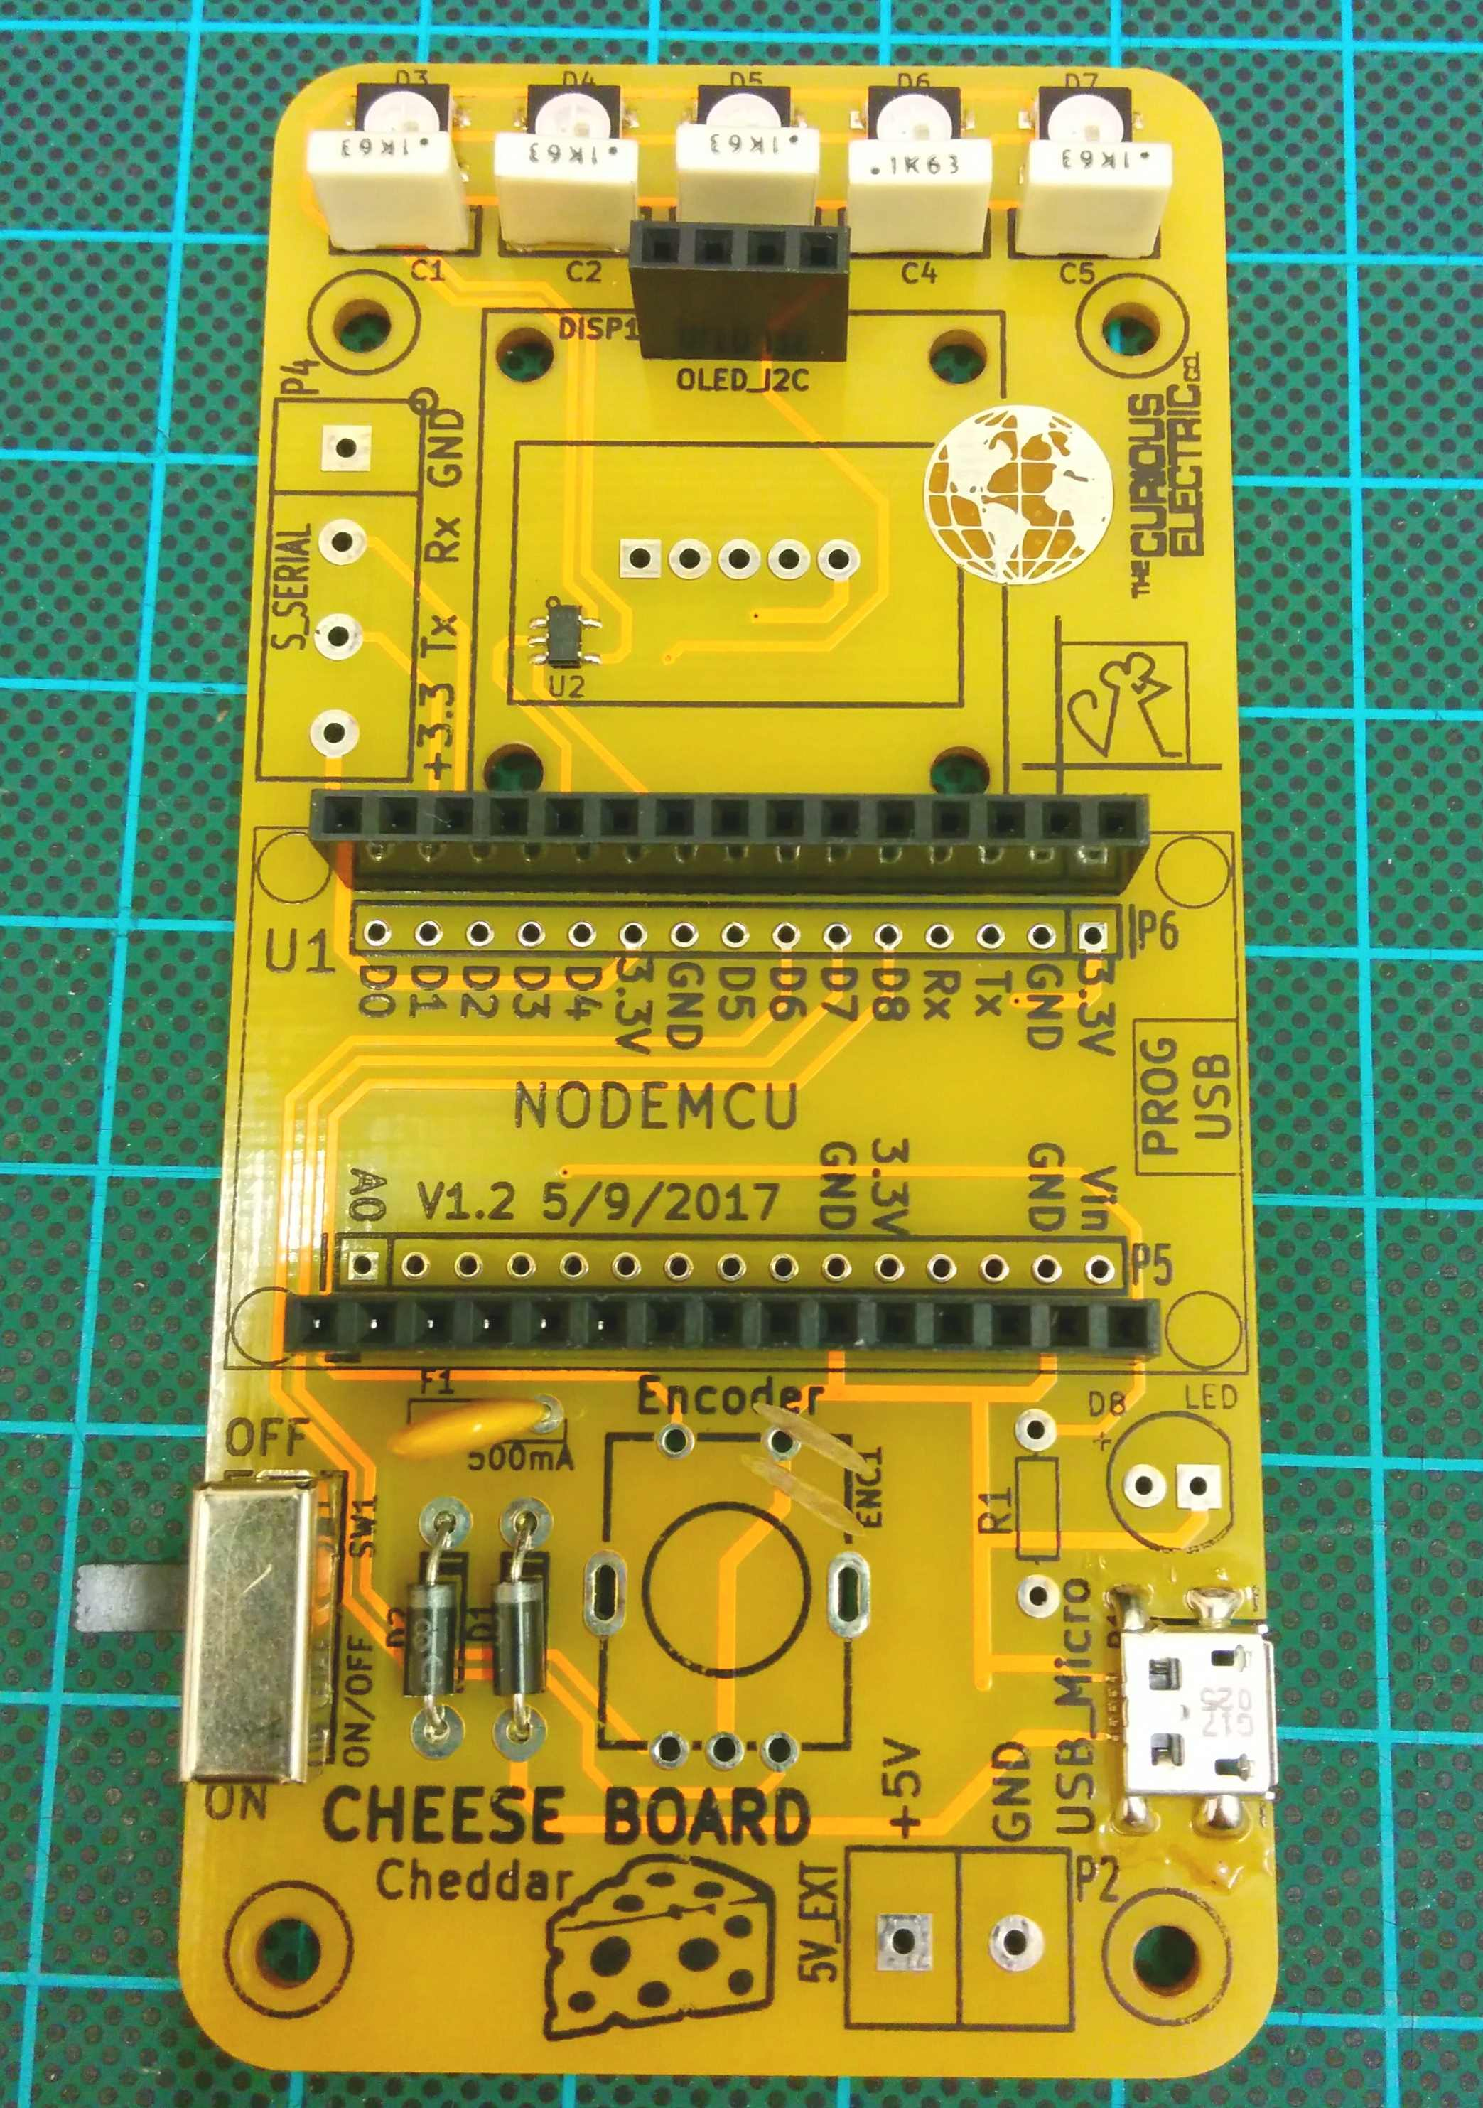  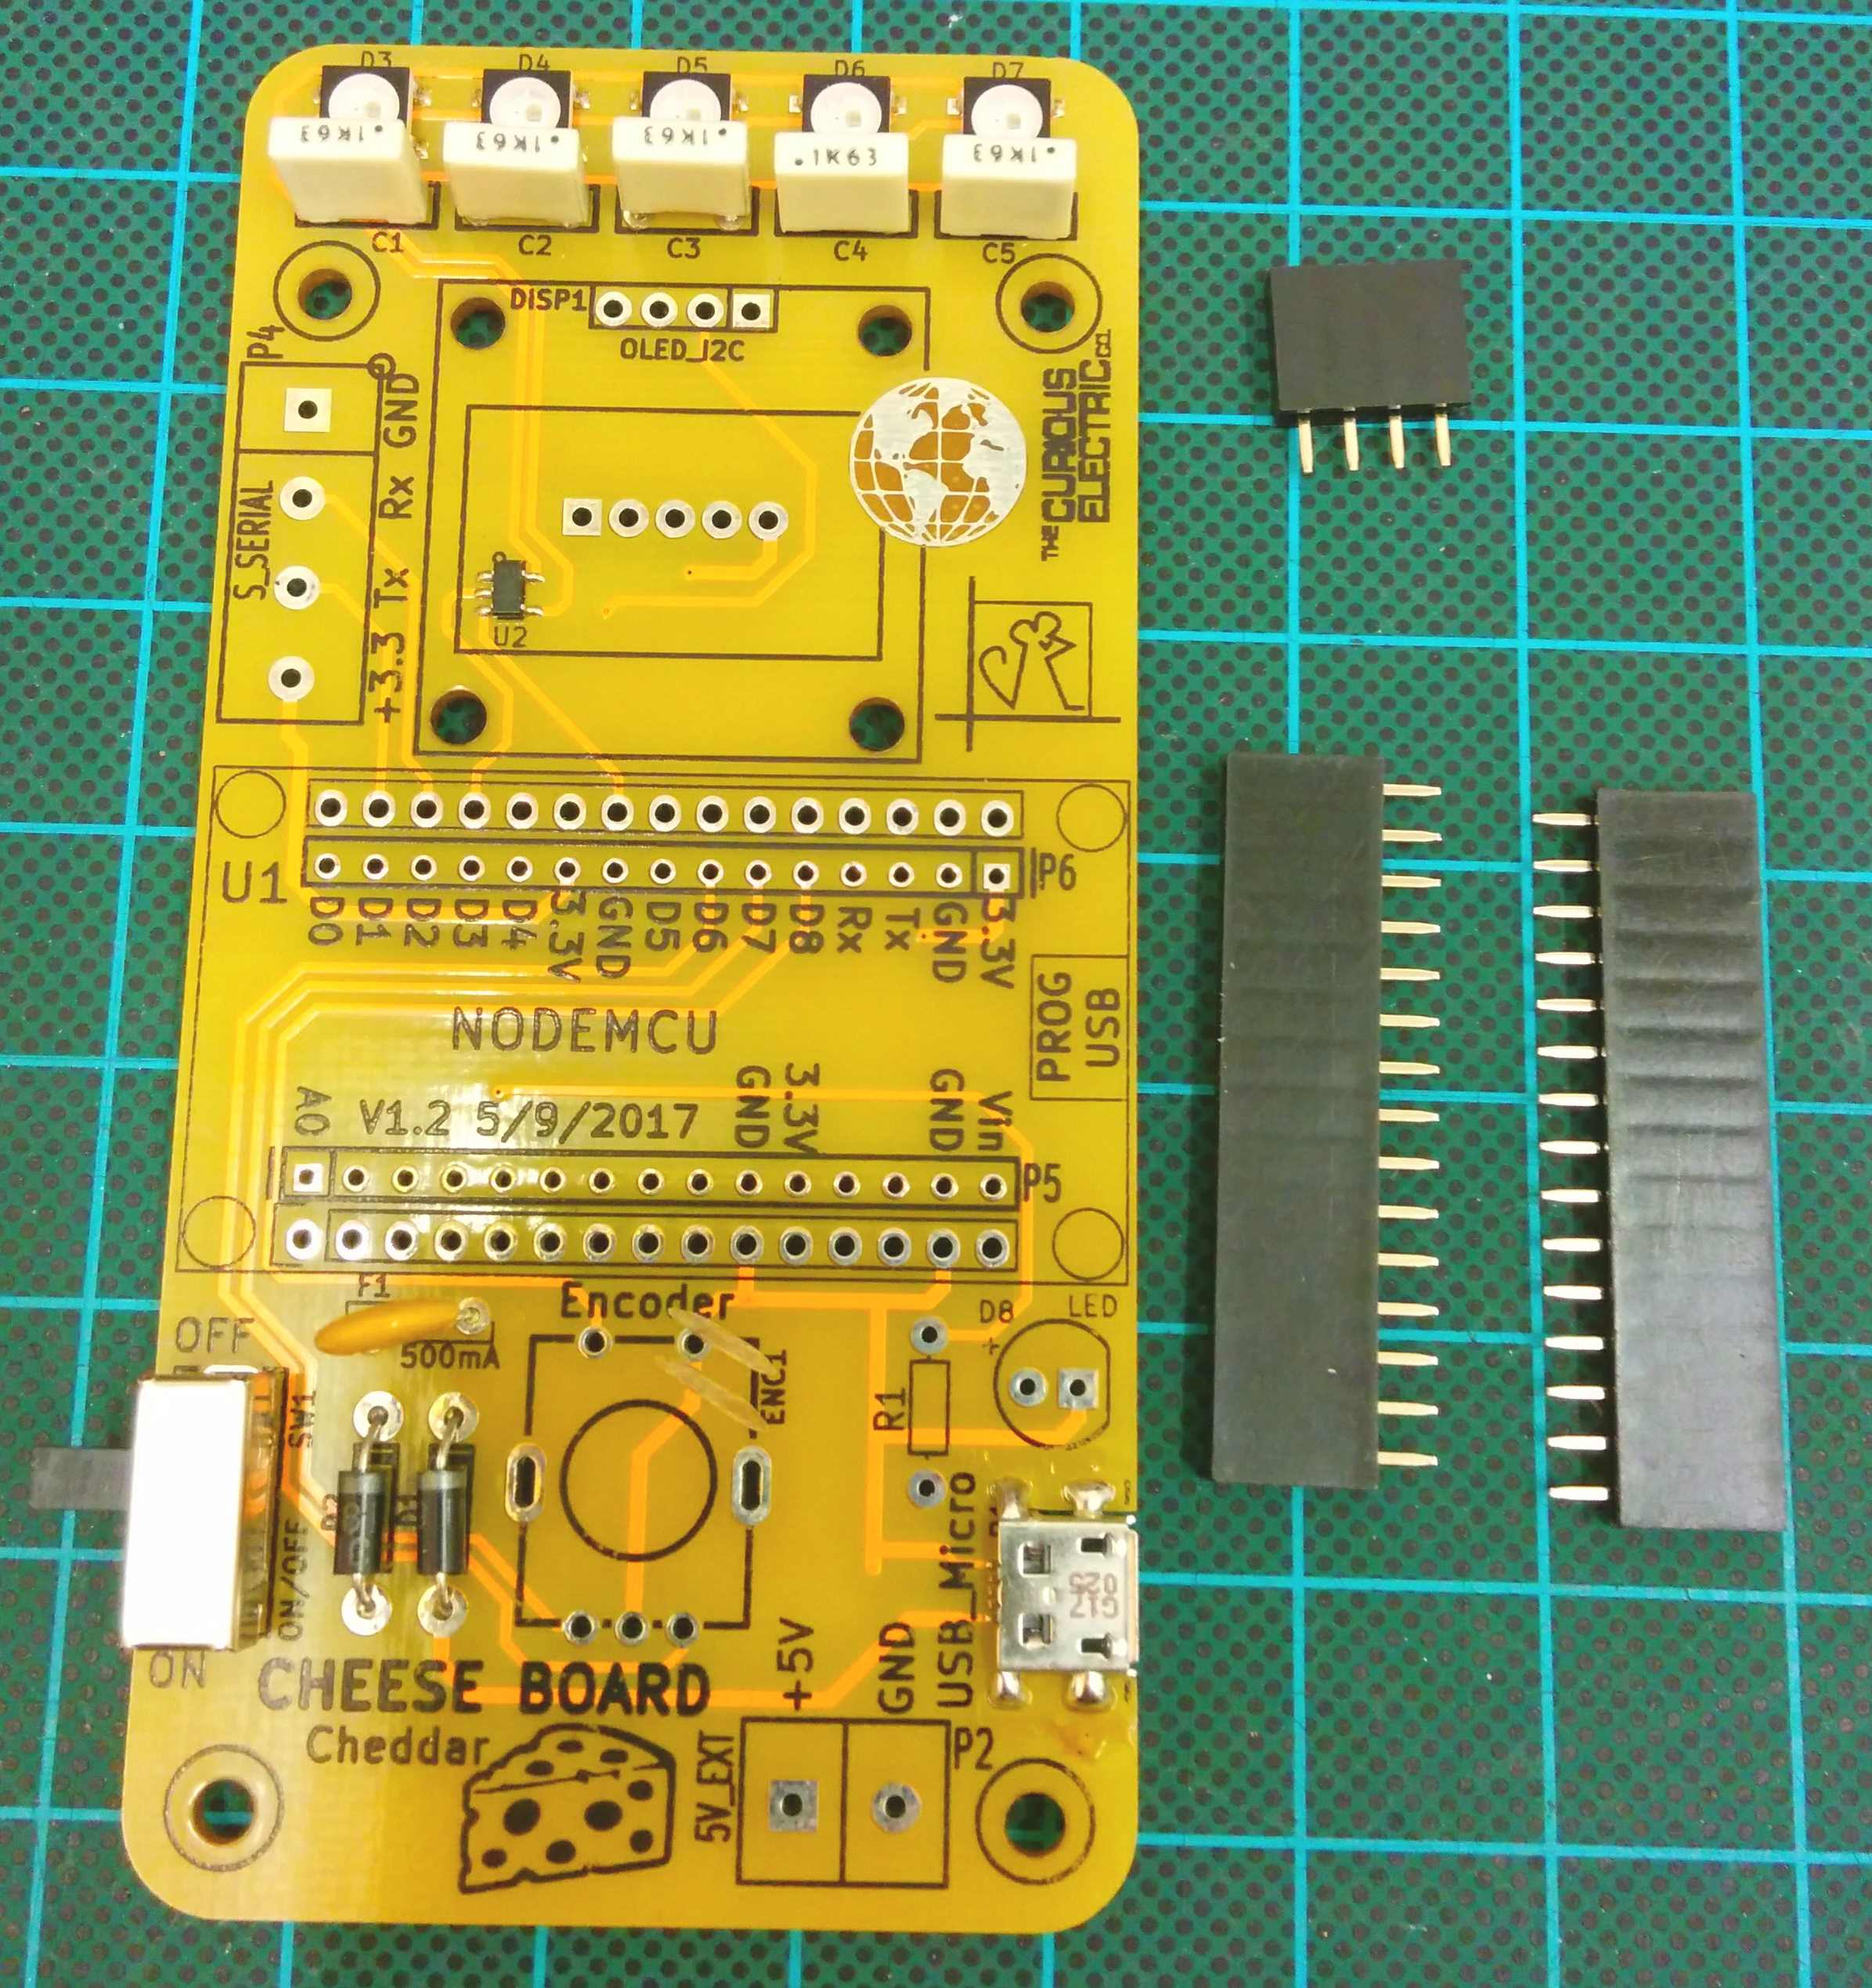

Step: 6 | Solder encoder
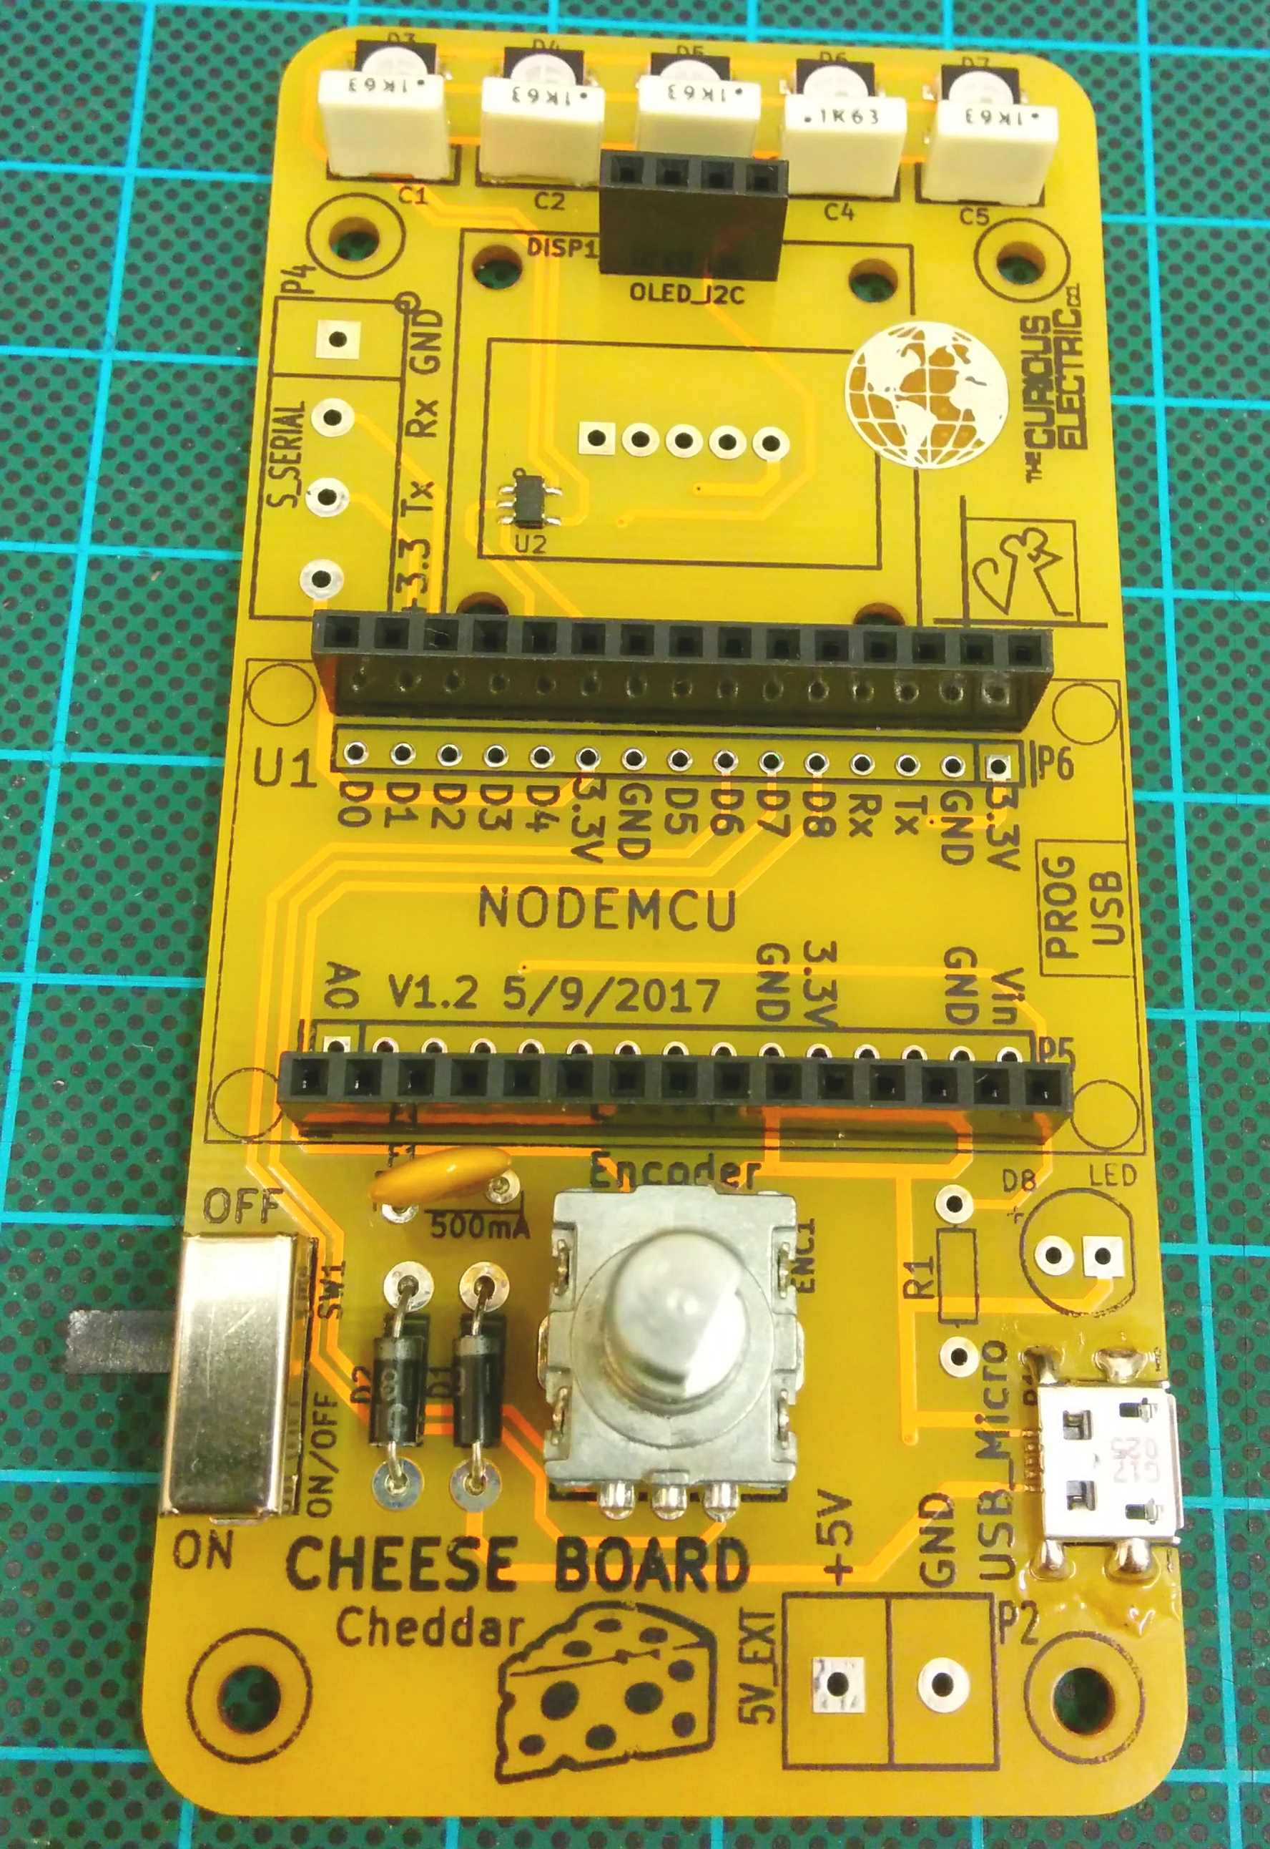  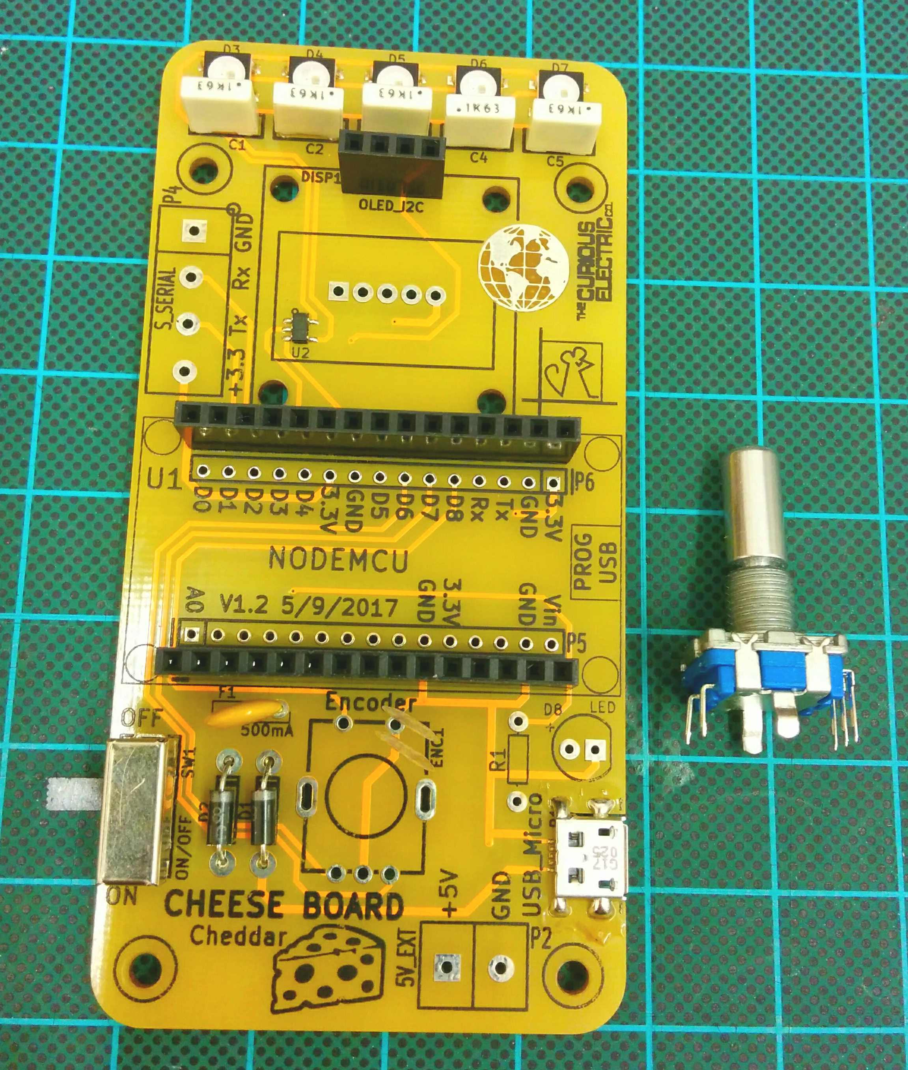 |  | The encoder is soldered into the area marked ENC1.  Solder the two larger pads first to hold the encoder in place. Ensure the encoder is straight when soldered, as this goes through the front of the case, with the plastic knob added at the end.

Step: 7 | Solder screw terminals (if needed)
This step is only required if you would like to add a wired power supply to the unit. Skip if not using this.

If an external 5V power supply will be used (rather than the micro USB connector), then you can solder a 2 way screw terminal connector to the pads marked 5V_EXT.
Ensure that +5V has the positive supply and GND is connected to 0V.

Step: 8 | Fit OLED module
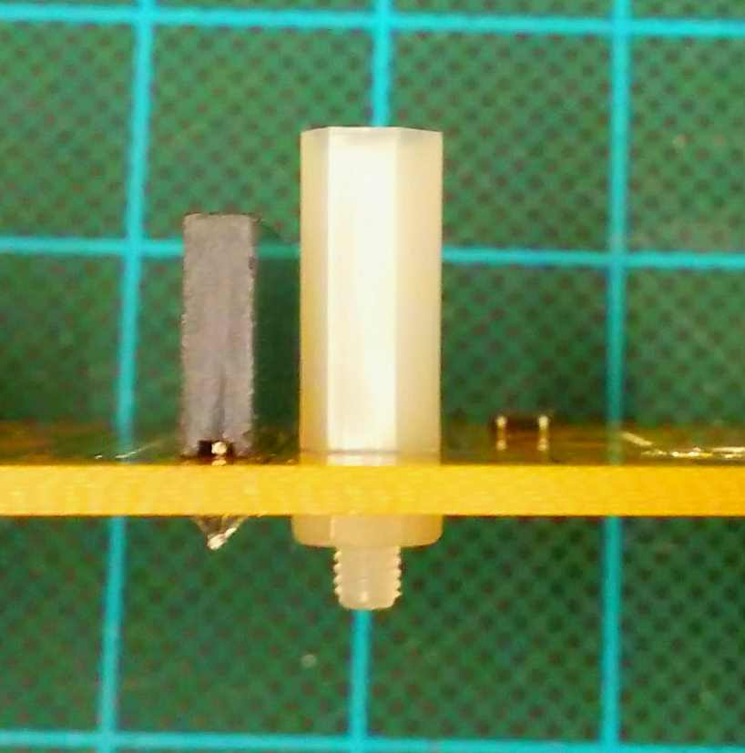  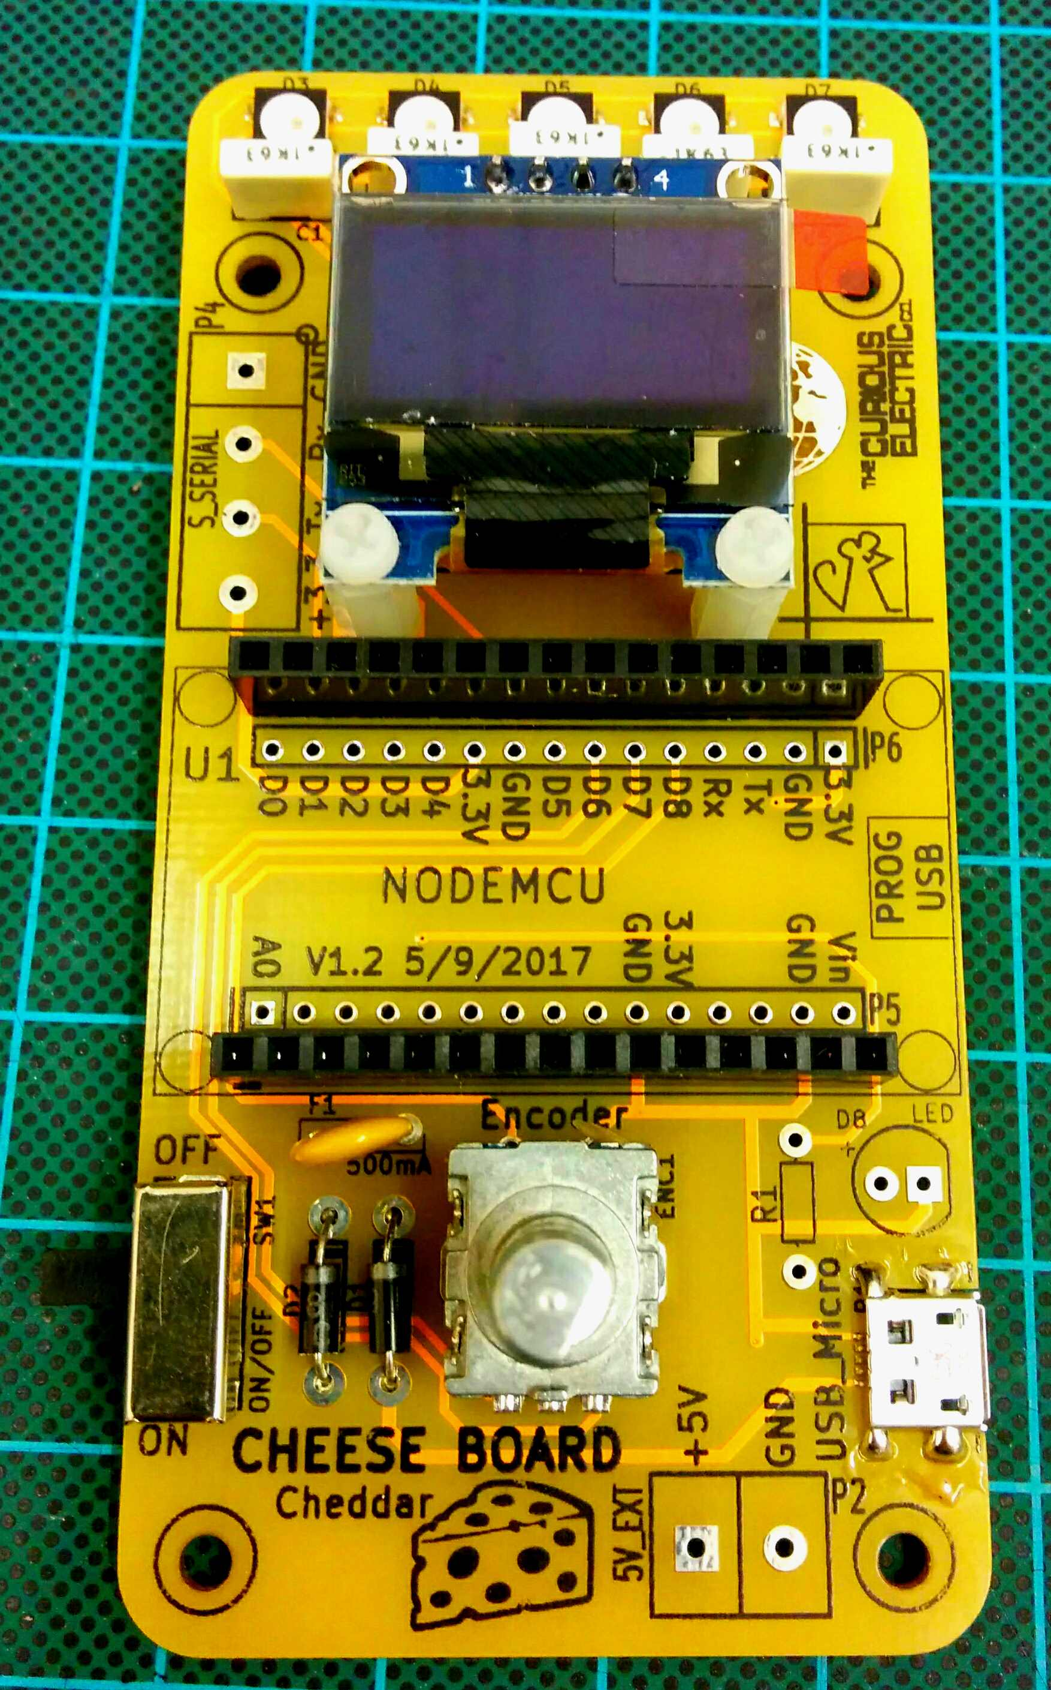  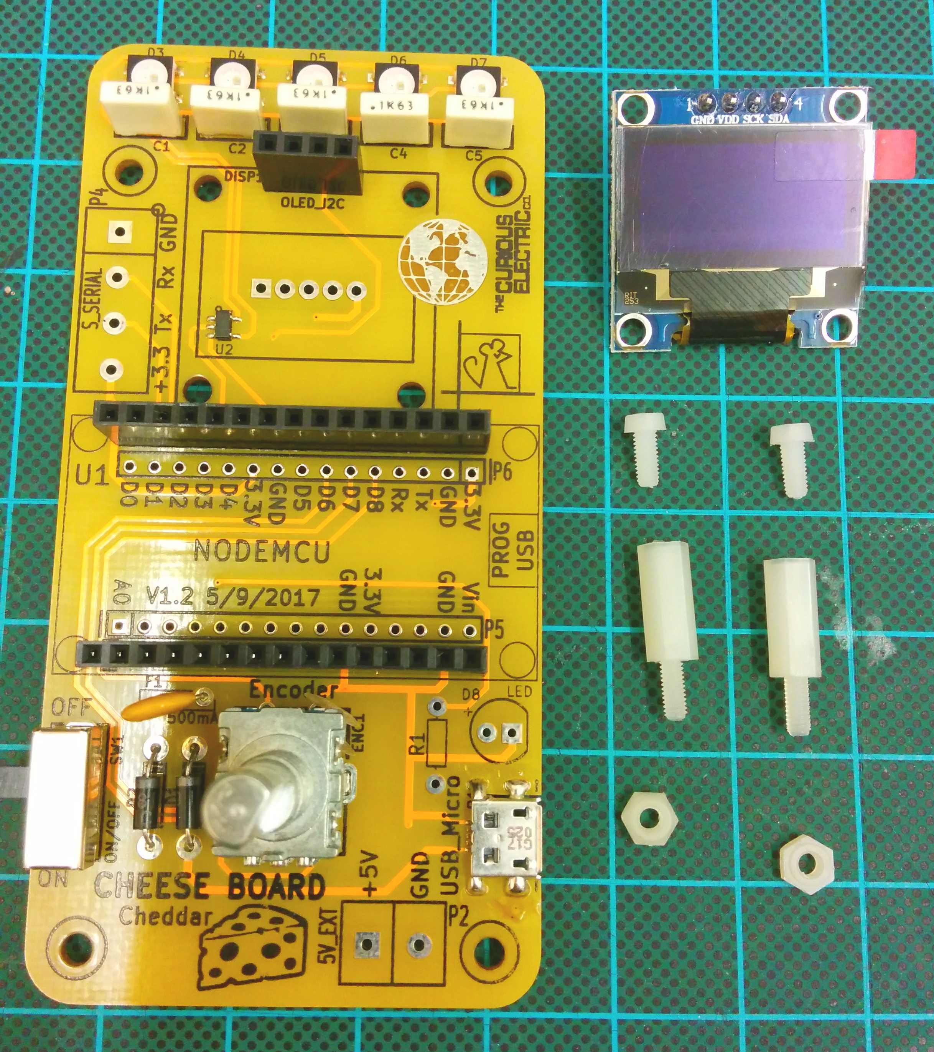 |  | The OLED unit pushes into the 4 way header pins soldered in step 6.  There are two 2.5mm spacers. The long plastic spacer is placed with the threaded male section through the holes and the nuts added to hold them in place.  Then put in the OLED module and fit the two 2.5mm machine screws from the top of the OLED module, as shown in the picture.

Step: 9 | Fit Node MCU
The NodeMCU unit pushes into the two 15 way header strips.  Ensure that the USB socket is above the ‘PROG USB’ area.  Double check this before powering on!  The NodeMCU has been pre-programmed with a test code. This should run when powered. |  | 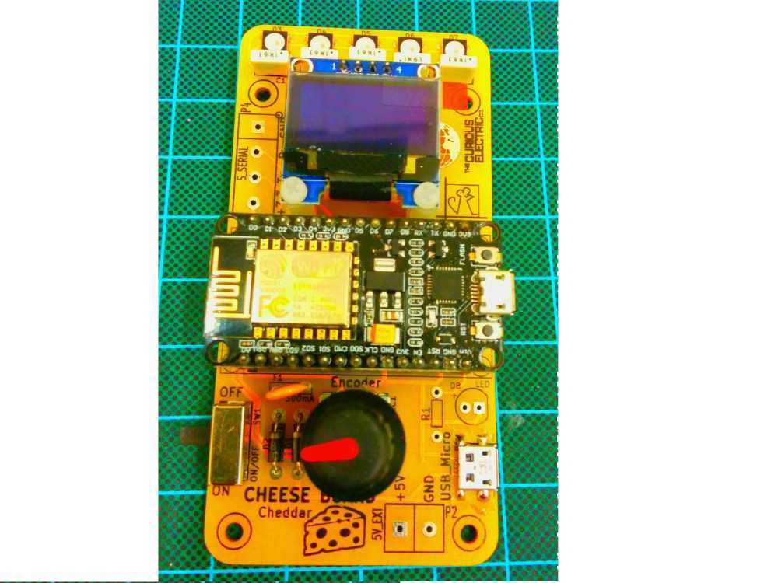

Step: 10 | PCB is finished!
Test with micro-USB cable. The USB power cable can either be plugged into the NodeMCU (used for programming the unit) or it can be plugged in to the USB_Micro socket (only used to power the unit – there is no communication through this socket).  Switch on and check:  - LEDs light  - OLED screen shows data  - Rotary Encoder changes data on OLED  This should prove that the functions of the PCB and the NodeMCU are working OK. |  | Have a nice cup of tea.  

Enclosure
Step: 11 | Remove protective plastic film
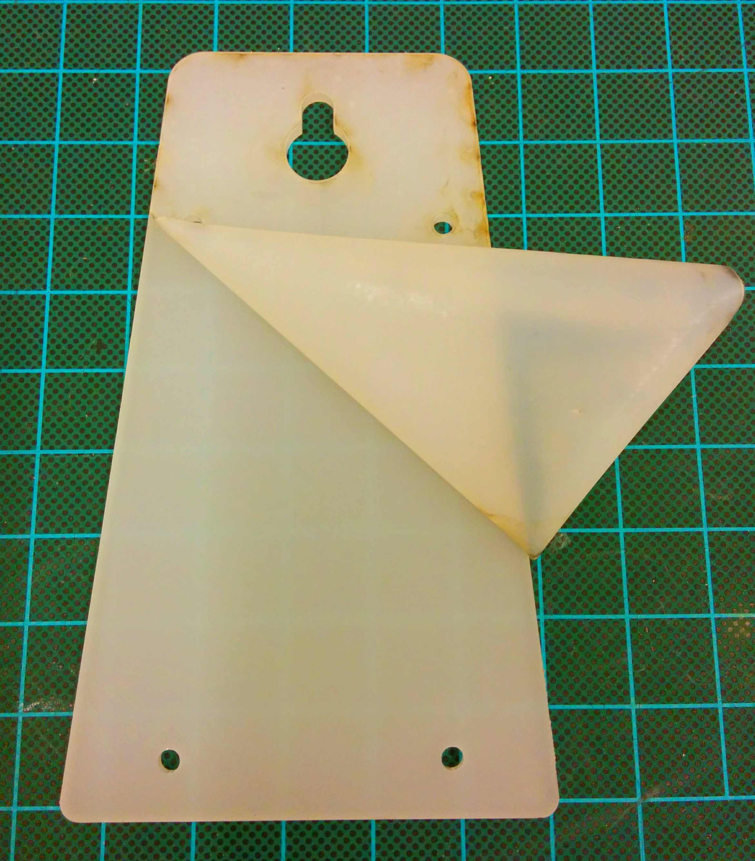

Step: 12 | Add spacer
There are four spacers to add, each one is comprised on a short spacer with male and female ends and a female-female longer spacer.  The shorted spacer should go through from the bottom of the PCB, with the longer spacer screwed on top, as shown in the picture. |  | 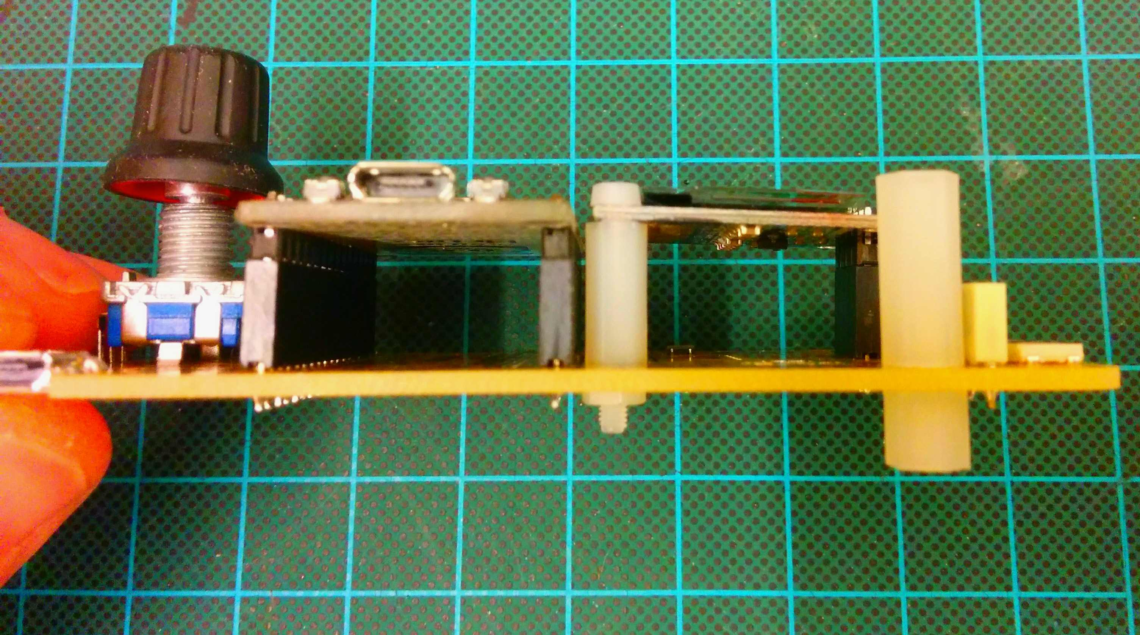  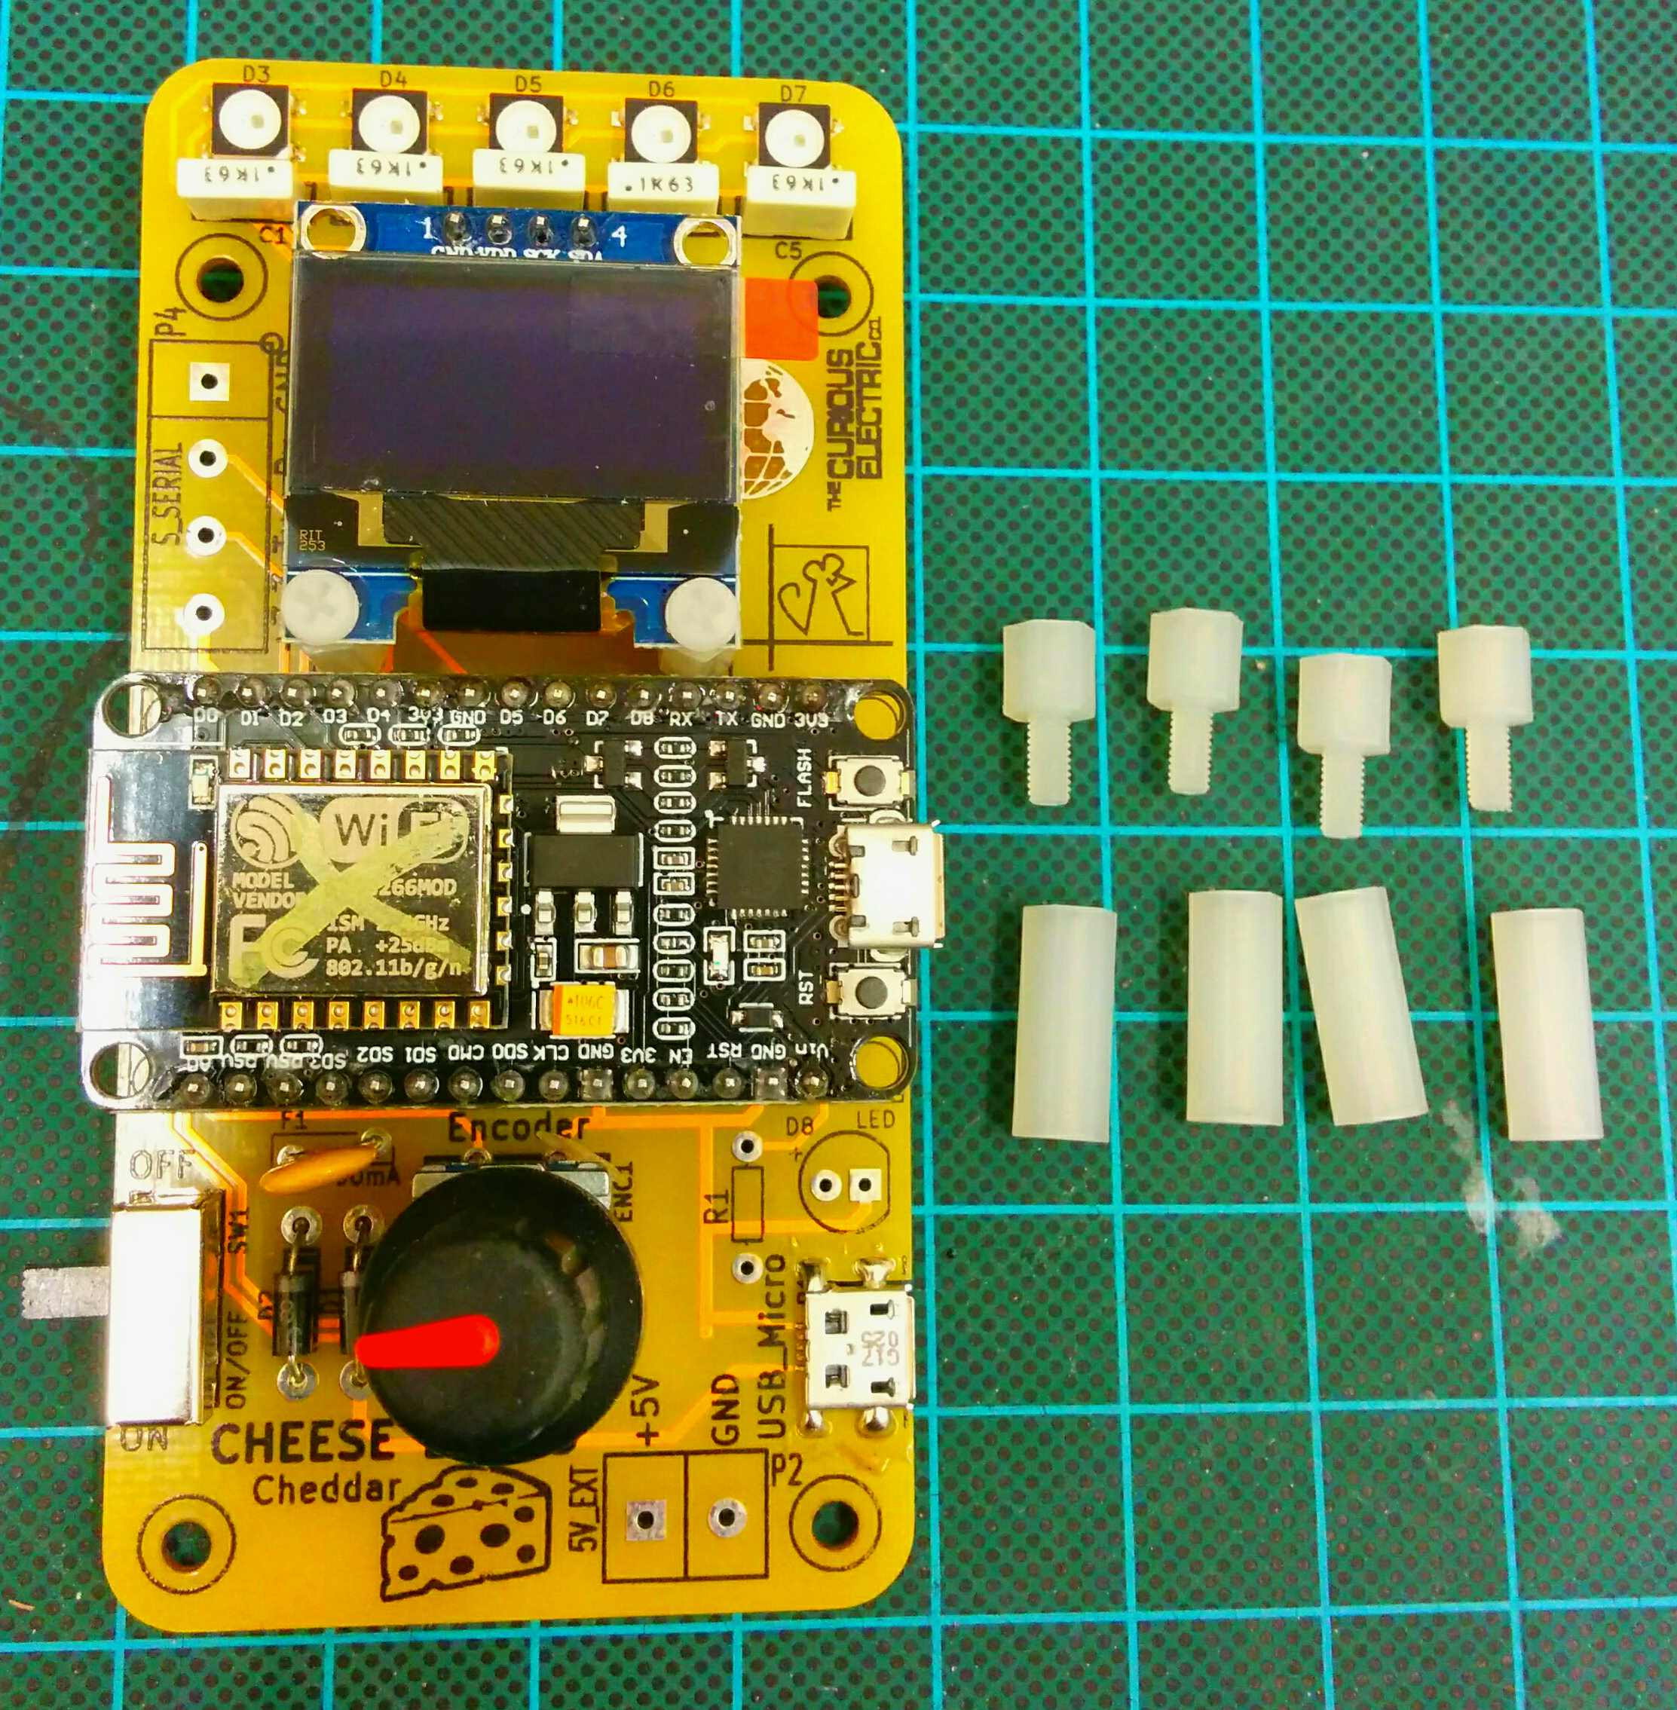

Step: 13 | Add enclosure and knob
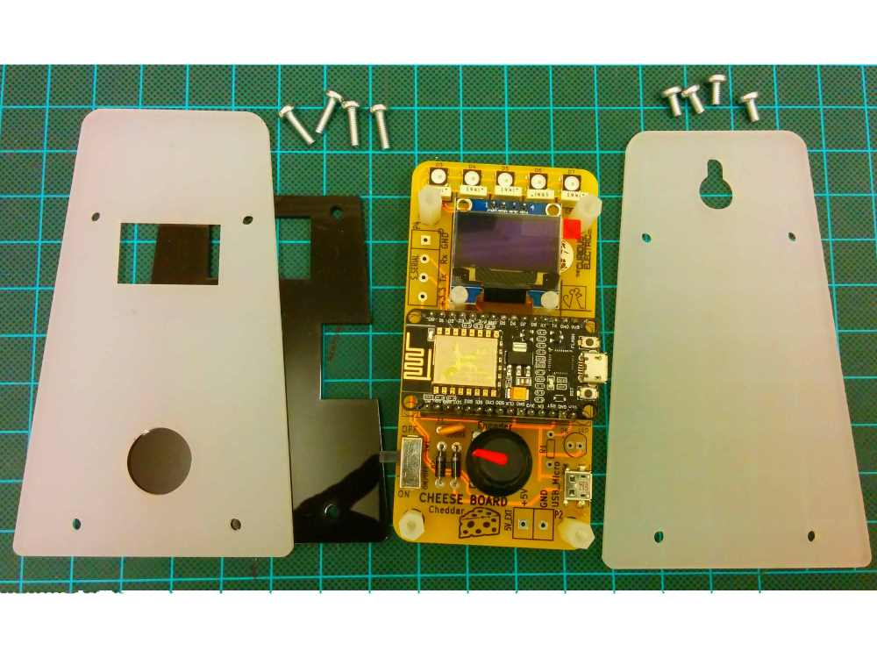  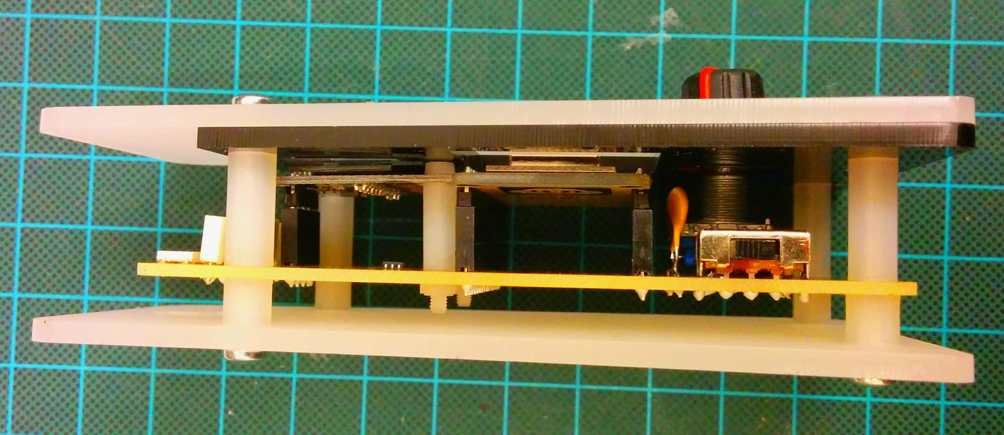 |  | The shorted M3 screws are used to hold the back enclosure plate in place. The back enclosure plate has a hook hole and also the company logo on it.  The front should have the black cover placed on first, then the front enclosuire plate added. The 15mm M3 screws then hold this in palce on the front of the unit into the spacers added in step 12.  The know for the rotary encoder can also be pushed on. This is sometimes a little difficult and requires some force.

Step: 14 | Finished build!
Now the unit can be plugged in and code uploaded.  The unit can be programmed to show data from the internet, or to upload data from the internet. It can also be used as a stand-alone unit.  The limit to this unit is only your imagination and coding skills! |  | 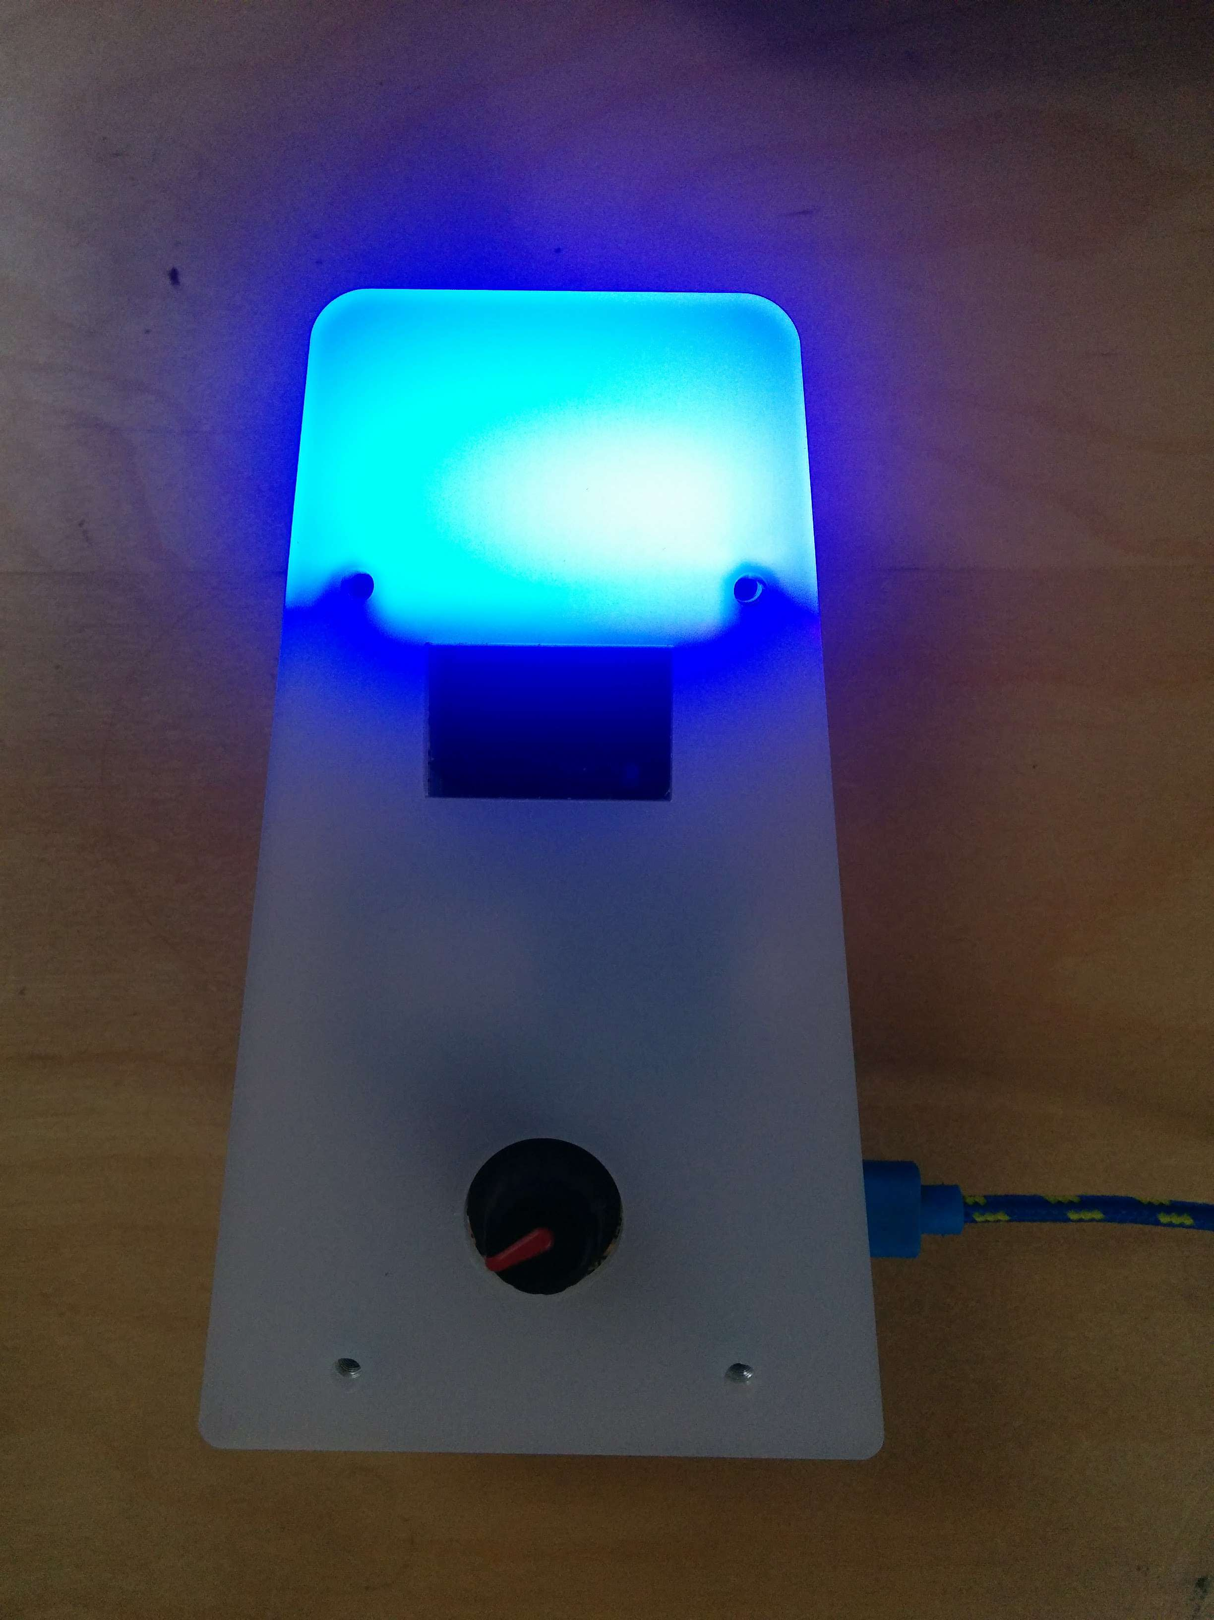

Software

Step: 15 | Upload software
This is where the fun begins!

This project has software stored on GITHUB software repository here:

https://github.com/curiouselectric/CheeseBoardCheddar

Please follow the readme in this file for the most up to date instructions for uploading code using the Arduino IDE (or any other IDE of your choice).

This GITHUB contains all the design files as well as the software code. Move to the software folder for the software examples and readme.

The software has example code which can be used to build your application. The most important part is setting up the wifi code and internet connection, which is described in the readme.

Contact details:
This kit has been designed and produced by:

The Curious Electric Company
hello@curiouselectric.co.uk
www.curiouselectric.co.uk
Hopkinson Gallery, 21 Station Street, Nottingham, UK, NG2 3AJ

We would like you to be happy with this kit. If you are not happy for any reason then please contact us and we will help to sort it out.

Please email hello@curiouselectric.co.uk with any questions or comments.
Please tweet us at @curiouselectric

If any parts are missing from your kit then please email hello@curiouselectric.co.uk with details, including when and where the kit was purchased.

More technical information can be found via www.curiouselectric.co.uk

Circuit Schematic:
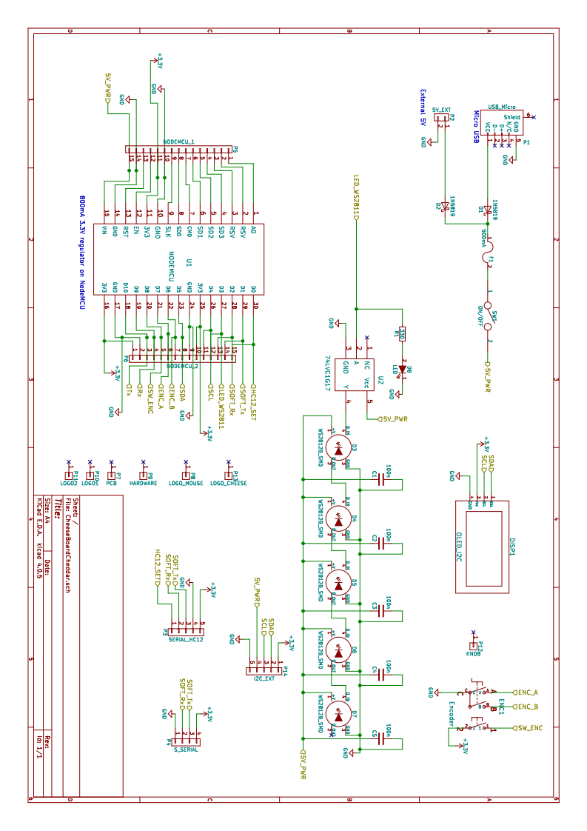

PCB Design:


